JAVA UNIT 3
Topic 1: What is a Thread?
A thread is the smallest unit of execution within a program. Java allows multiple threads to run concurrently inside a single program — this is called multithreading.
Think of it like a restaurant kitchen: the chef (main program) can have multiple cooks (threads) working at the same time — one chopping, one boiling, one grilling.
Key facts:
- Every Java program has at least one thread — the main thread
- The JVM (Java Virtual Machine) manages thread scheduling
- Threads share the same memory space (heap), but each has its own stack
Topic 2: Creating Threads — Two Ways
- Way 1: Extending Thread class
java
class MyThread extends Thread {
String name;

MyThread(String name) {
this.name = name;
}

@Override
public void run() {
Sleep
Thread.sleep(300);
Pause thread for 300 ms.
Allows thread switching/interleaving.
for (int i = 1; i <= 3; i++) {
System.out.println(name + " is running - count: " + i);
try {
Thread.sleep(500); // pause for 500ms
} catch (InterruptedException e) {
System.out.println(name + " was interrupted");
}
}
}
}

public class ThreadDemo {
public static void main(String[] args) {
MyThread t1 = new MyThread("Thread-A");
MyThread t2 = new MyThread("Thread-B");

t1.start(); // DO NOT call run() directly — always use start()
t2.start();

System.out.println("Main thread finished launching threads!");
}
}

Sample Output:
Main thread finished launching threads!
Thread-A is running - count: 1
Thread-B is running - count: 1
Thread-A is running - count: 2
Thread-B is running - count: 2
...
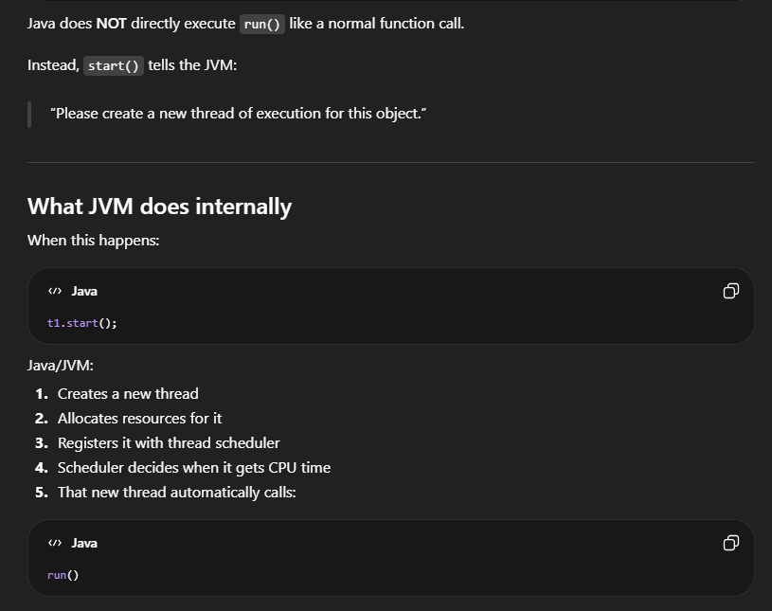
⚠️ Important: Always call .start(), never .run() directly. Calling .run() just executes it sequentially — no new thread is created!
CPU rapidly switches between multiple threads
On Multi-Core CPUs
Modern CPUs may actually run threads truly simultaneously.
start() creates new independent threads of execution. The operating system scheduler then manages CPU time between them, allowing concurrent execution.
That is basically the real multithreading concept.

- Way 2: Implementing Runnable Interface
class MyTask implements Runnable {
String taskName;

MyTask(String taskName) {
this.taskName = taskName;
}

@Override
public void run() {
for (int i = 1; i <= 3; i++) {
System.out.println(taskName + " executing step: " + i);
try {
Thread.sleep(300);
} catch (InterruptedException e) {
e.printStackTrace();
}
}
}
}
public class RunnableDemo {
public static void main(String[] args) {
MyTask task1 = new MyTask("Download");
MyTask task2 = new MyTask("Upload");

Thread t1 = new Thread(task1); // wrap Runnable in Thread
Thread t2 = new Thread(task2);

t1.start();
t2.start();
}
}
✅ Prefer Runnable — because Java doesn't support multiple inheritance. If your class already extends something else, you can't extend Thread too. Runnable saves the day!
VERY IMPORTANT
Extends means:
IS-A relationship
Example:
MyThread IS A Thread

So MyThread automatically gets:
- start()
- sleep()
- thread behavior
because they already exist in Thread.

Runnable is a Java interface.
It represents:
something whose work can be run
RUNNABLE DEFINES TASK
THEN CREATES ITS THREAD

Extend Thread vs Runnable — Quick Comparison:
 | extends Thread | implements Runnable
Inheritance | Uses up your one extends slot | Frees it for other classes
Flexibility | Less flexible | More flexible
Best for | Simple, standalone threads | Recommended approach

Now let's see the thread lifecycle as a flowchart:
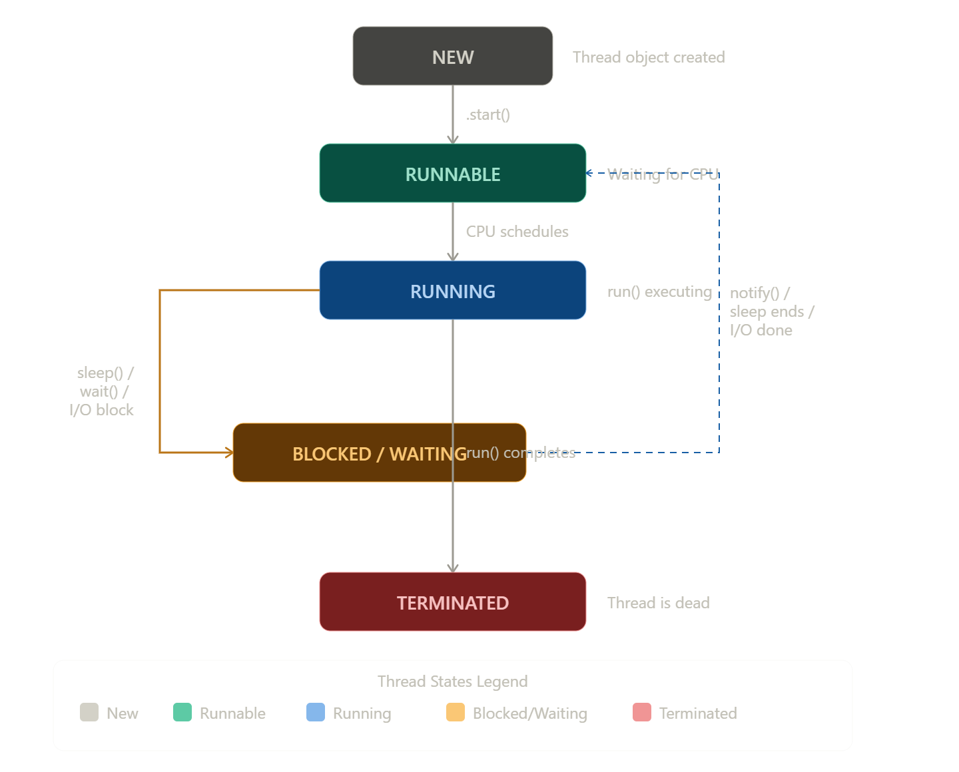
Sometimes thread cannot continue immediately.
Example:
Thread.sleep(500);
Now thread pauses.
It enters:
BLOCKED / WAITING

Only one thread per CPU core can truly run at one exact moment. Scheduler rapidly switches between threads.
Topic 2: Thread Priority
In Java, every thread has a priority — a number between 1 and 10 that hints to the JVM scheduler which thread should get CPU time first.
Constant | Value | Meaning
Thread.MIN_PRIORITY | 1 | Lowest priority
Thread.NORM_PRIORITY | 5 | Default (every thread starts here)
Thread.MAX_PRIORITY | 10 | Highest priority
⚠️ Priority is a hint, not a guarantee. The OS/JVM scheduler may or may not respect it — behavior can vary across platforms.

Real Working Example — Thread Priority

class PriorityThread extends Thread {
public PriorityThread(String name) {
super(name); // sets thread name
}

@Override
public void run() {
for (int i = 1; i <= 3; i++) {
System.out.println(getName() +
" | Priority: " + getPriority() +
" | Step: " + i);
}
}
}

public class PriorityDemo {
public static void main(String[] args) {

PriorityThread low = new PriorityThread("LOW ");
PriorityThread normal = new PriorityThread("NORMAL");
PriorityThread high = new PriorityThread("HIGH ");
// Set priorities BEFORE calling start()
low.setPriority(Thread.MIN_PRIORITY); // 1
normal.setPriority(Thread.NORM_PRIORITY); // 5
high.setPriority(Thread.MAX_PRIORITY); // 10

// Start all threads
low.start();
normal.start();
high.start();
}
}
Expected Output (HIGH tends to run first):
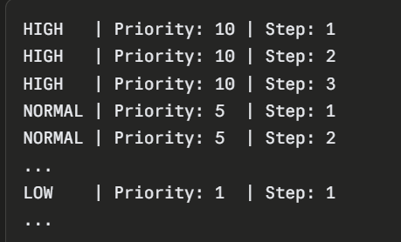
Key methods:
- setPriority(int p) — set before start()
- getPriority() — returns current priority
- Thread.currentThread() — get the currently running thread
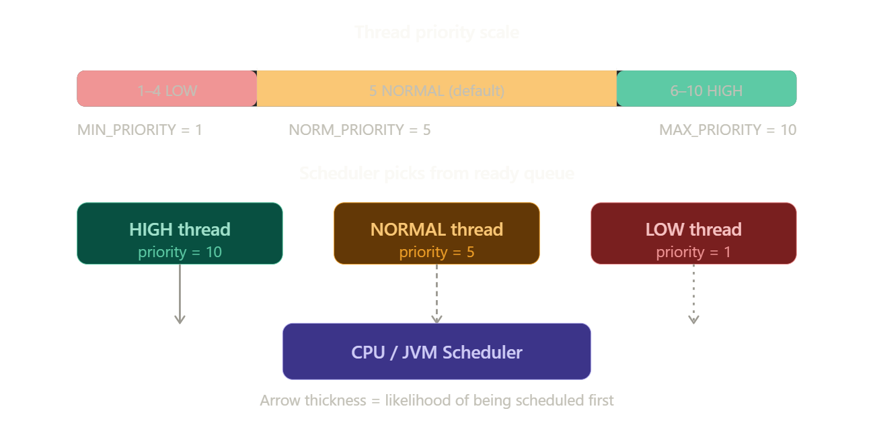
Topic 3: Blocked States (Thread States Deep Dive)
A thread doesn't always go straight from Running → Terminated. It can get blocked in several ways:
Blocked Reason | How it happens | How it unblocks
Sleeping | Thread.sleep(ms) | Timer expires
Waiting | wait() called | Another thread calls notify()
I/O Blocked | Waiting for file/network | I/O operation completes
Lock Blocked | Another thread holds the lock | Lock is released
Joining | t.join() called | Target thread finishes
Real Working Example — Blocked States
class MyThread extends Thread {

public void run() {

System.out.println("Thread started");

try {
System.out.println("Thread is sleeping...");

Thread.sleep(3000); // wait for 3 seconds

} catch (InterruptedException e) {
e.printStackTrace();
}

System.out.println("Thread woke up");
}
}

public class WaitingDemo {

public static void main(String[] args) throws Exception {

MyThread t1 = new MyThread();

t1.start();

Thread.sleep(500); // wait a little before checking state

System.out.println("Current state: " + t1.getState());
}
}

Output:
Thread started
Thread is sleeping...
Current state: TIMED_WAITING
Thread woke up
Java's official thread state enum (Thread.State):
- NEW — created, not started
- RUNNABLE — running or ready to run
- BLOCKED — waiting to acquire a lock
- WAITING — waiting indefinitely (wait(), join())
- TIMED_WAITING — waiting with a timeout (sleep(), wait(ms))
- TERMINATED — finished
Topic 4: Thread Synchronization
Why do we need it?
When multiple threads access shared data simultaneously, they can corrupt it. This is called a Race Condition.
Real Problem First — Without Synchronization
class Counter {
int value = 0;
void increment() {
System.out.println(Thread.currentThread().getName()
+ " is incrementing");
try {
Thread.sleep(100); // simulate delay
} catch (InterruptedException e) {}
value++;
System.out.println(Thread.currentThread().getName()
+ " done. Value = " + value);
}
}

public class RaceConditionDemo {
public static void main(String[] args) {
Counter counter = new Counter(); // shared object
Thread t1 = new Thread(() -> counter.increment(), "Thread-A");
Thread t2 = new Thread(() -> counter.increment(), "Thread-B");

t1.start();
t2.start();
}
}

Example
Two threads each increment 3 times.
Expected:
6
because:
3 + 3 = 6

Without synchronization
Some increments get lost because threads overwrite each other’s updates.
So possible final values: 4 5 6 …
Output:
Thread-A is incrementing
Thread-B is incrementing
Thread-A done. Value = 1
Thread-B done. Value = 1
Solution 1: Synchronized Method
Add synchronized keyword to the method. Only one thread can execute it at a time.
class Counter {
int value = 0;
synchronized void increment() {
System.out.println(Thread.currentThread().getName() + " is incrementing");
try {
Thread.sleep(100);
} catch (InterruptedException e) {}
value++;
System.out.println(Thread.currentThread().getName() + " done. Value = " + value);
}
}
public class SyncMethodDemo {
public static void main(String[] args) {
Counter counter = new Counter();
Thread t1 = new Thread(() -> counter.increment(), "Thread-A");
Thread t2 = new Thread(() -> counter.increment(), "Thread-B");
t1.start();
t2.start();
}
}
Safe Output:
Thread-A is incrementing
Thread-A done. Value = 1
Thread-B is incrementing
Thread-B done. Value = 2
🔒 Solution 2: Synchronized Block
Sometimes you don't want to lock the entire method — only the critical section. This is more efficient.
class Counter {
int value = 0;
void increment() {
System.out.println(Thread.currentThread().getName() + " entered method");
synchronized(this) {
try {
Thread.sleep(100);
} catch (InterruptedException e) {}
value++;
System.out.println(Thread.currentThread().getName() + " updated value = " + value);
}
}
}
public class SyncBlockDemo {
public static void main(String[] args) {
Counter counter = new Counter();
Thread t1 = new Thread(() -> counter.increment(), "Thread-A");
Thread t2 = new Thread(() -> counter.increment(), "Thread-B");

t1.start();
t2.start();
}
}

Synchronized Method vs Block — Exam Table

 | Synchronized Method | Synchronized Block
Locks | Entire method | Only critical section
Performance | Slower (over-locking) | Faster (precise locking)
Syntax | synchronized void method() | synchronized(this){ }
Use when | Whole method is critical | Only part needs protection

Topic 5: Overriding Synchronized Methods
This is a tricky exam concept — what happens when you override a synchronized method?
class Parent {
synchronized void display() {
System.out.println("Parent synchronized display");
}
}
class Child extends Parent {
// Override WITHOUT synchronized — this is ALLOWED
// But now it is NO longer synchronized!
@Override
void display() {
System.out.println("Child display — NOT synchronized!");
}
}
class ChildSynced extends Parent {
// Override WITH synchronized — stays synchronized ✅
@Override
synchronized void display() {
System.out.println("ChildSynced display — still synchronized!");
}
}
public class OverrideSyncDemo {
public static void main(String[] args) {
Parent p = new Child();
p.display(); // calls Child's version — NOT synchronized!
Parent p2 = new ChildSynced();
p2.display(); // calls ChildSynced's version — synchronized ✅
}
}
OUTPUT:
Child display — NOT synchronized!
ChildSynced display — still synchronized!
⚠️ Exam Key Point: synchronized is NOT inherited. When you override a synchronized method, the child's version is not automatically synchronized. You must explicitly add synchronized again.
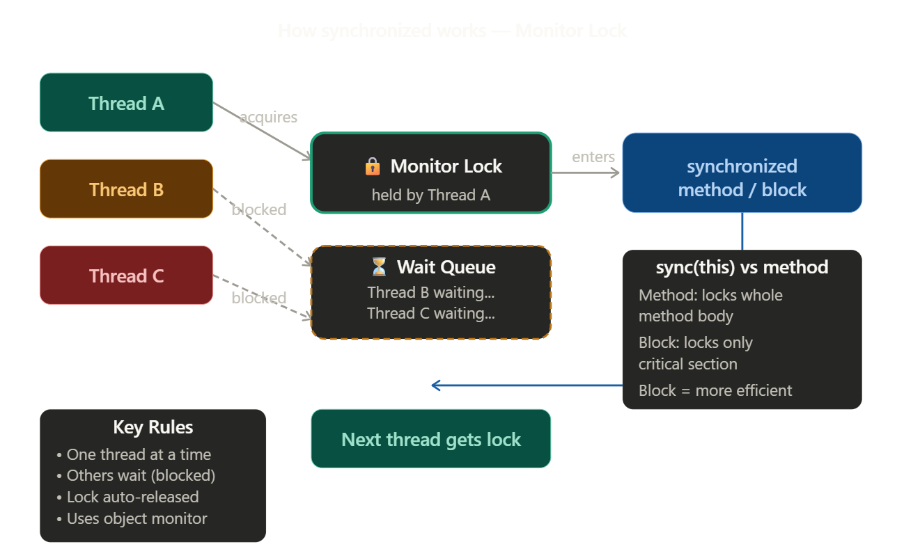

VERY IMPORTANT
The printed output itself is not the real difference.
The REAL difference is:
thread safety
With synchronized
Only one thread allowed at a time.
Safe shared-data access.

Without synchronized
Multiple threads can enter method simultaneously.
Possible race conditions.
Topic 6: Thread Communication — wait(), notify(), notifyAll()
Why do we need it?
Synchronization prevents threads from clashing. But sometimes threads need to talk to each other — one thread produces data, another consumes it. They need to coordinate.
Classic example: Producer-Consumer Problem
- Producer makes items → puts in buffer
- Consumer takes items → from buffer
- If buffer is empty → Consumer must wait
- If buffer is full → Producer must wait

The 3 Methods — All called inside synchronized only!
Method | What it does
wait() | Releases lock + pauses thread until notified
notify() | Wakes up one waiting thread
notifyAll() | Wakes up all waiting threads
⚠️ Exam Critical: All three must be called inside a synchronized block/method, otherwise you get IllegalMonitorStateException!

Real Working Example — Producer Consumer
class Buffer {
int item;
boolean available = false;
synchronized void produce(int value) throws InterruptedException {
while(available) {
wait();
}
item = value;
available = true;
System.out.println("Produced: " + item);
notify();
}
synchronized void consume() throws InterruptedException {
while(!available) {
wait();
}
System.out.println("Consumed: " + item);
available = false;
notify(); //OR YOU CAN USE notifyAll()
}
}
public class Demo {
public static void main(String[] args) {
Buffer b = new Buffer();
Thread producer = new Thread(() -> {
for(int i = 0; i < 5; i++) {
try {
b.produce(10);
Thread.sleep(500);
} catch(Exception e) {}
}
});
Thread consumer = new Thread(() -> {
for(int i = 0; i < 5; i++) {
try {
b.consume();
Thread.sleep(800);
} catch(Exception e) {}
}
});
producer.start();
consumer.start();
}
}
Output:
Produced: 10
Consumed: 10
Produced: 20 Consumed: 20 …. TILL 50
notify() vs notifyAll() — Exam Favourite!
class NotifyDemo {
synchronized void notifyOne() throws InterruptedException {
notify(); // wakes ONE random waiting thread
// other threads keep waiting
}

synchronized void notifyEveryone() throws InterruptedException {
notifyAll(); // wakes ALL waiting threads
// they compete for the lock
// only ONE gets it at a time
}
}
 | notify() | notifyAll()
Wakes | 1 random thread | All waiting threads
Use when | Only 1 thread needs to act | Multiple threads may need to act
Risk | Other threads may starve | Safer, no starvation
Performance | Slightly faster | Slightly slower
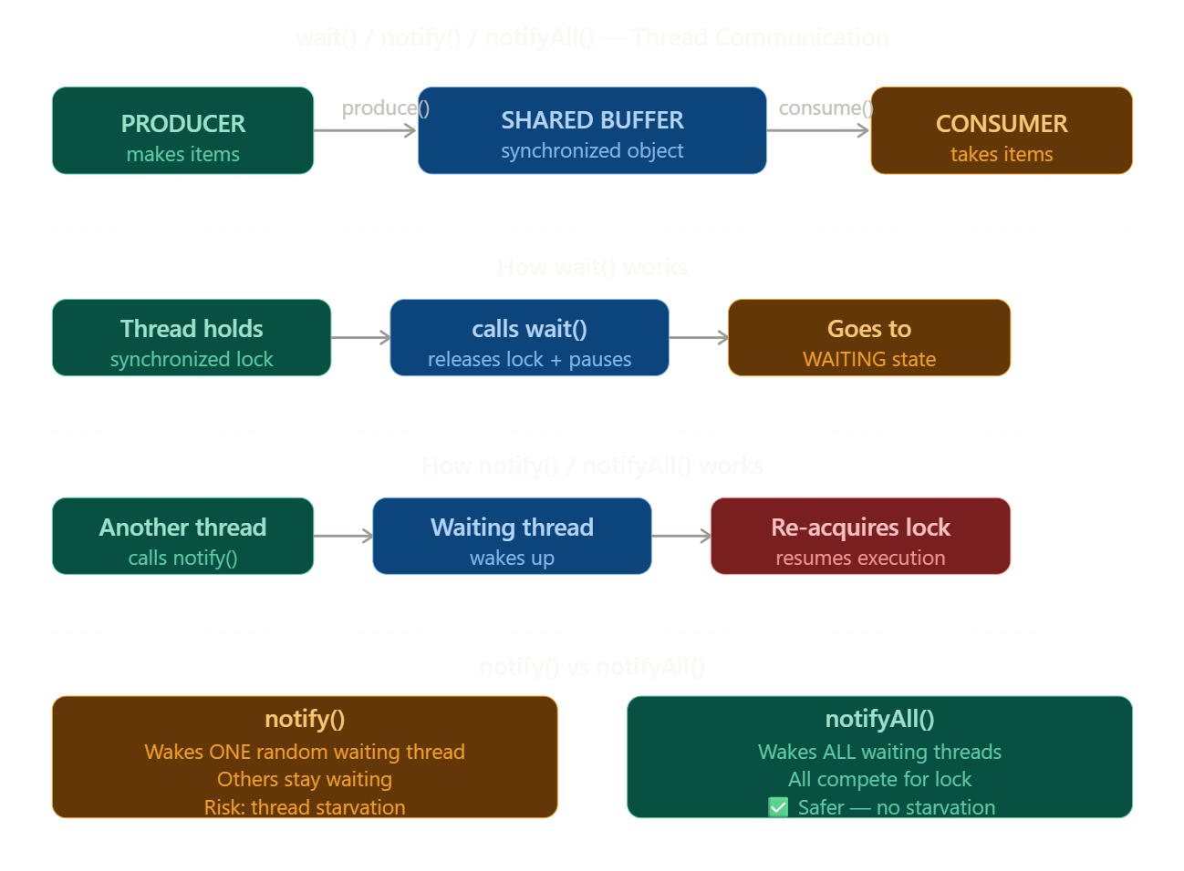

Topic 7: AWT — Abstract Window Toolkit
AWT is Java's built-in library for creating Graphical User Interfaces (GUIs) — windows, buttons, text fields, etc.
Example:
- calculator window
- login form
- notepad-like app

The AWT Class Hierarchy
Everything in AWT flows from one root — Component.
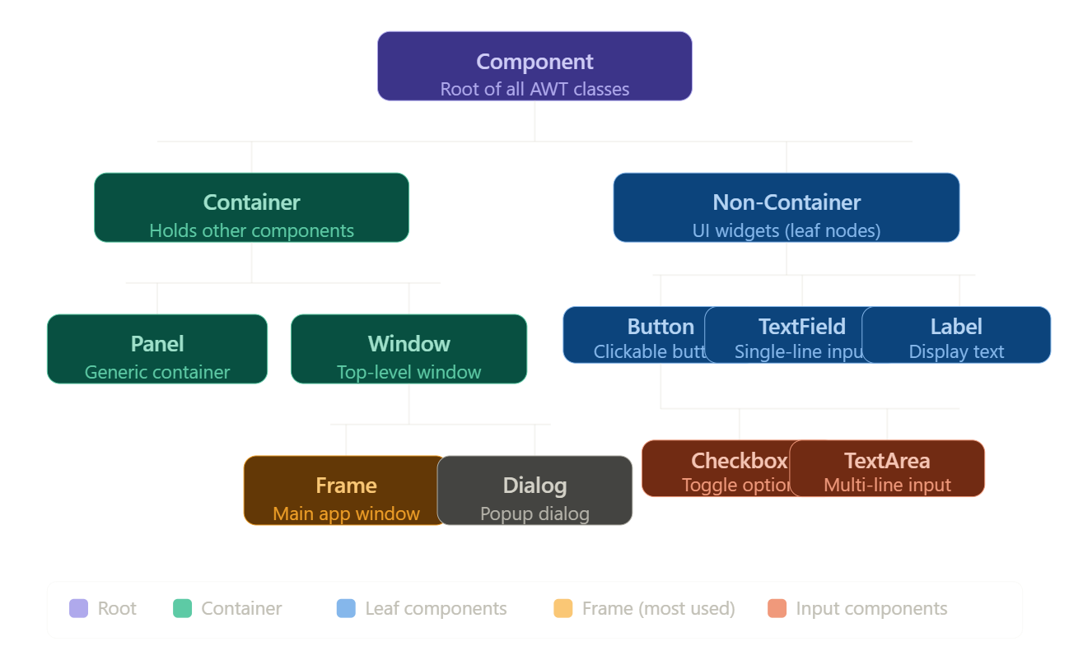
AWT Hierarchy Concept
Everything starts from: Component
Component Class in AWT
The Component class in Java AWT (Abstract Window Toolkit) is the root superclass of all GUI elements. It's an abstract class in the java.awt package that represents any object that can be displayed on screen and interact with the user.

Key Characteristics
Package: java.awt.Component Type: Abstract class Implements: ImageObserver, MenuContainer, Serializable
Class Hierarchy
java.lang.Object
└── java.awt.Component (abstract)
├── Button, Label, TextField, Checkbox...
└── Container
├── Panel, ScrollPane...
└── Window
├── Frame
└── Dialog

Commonly Used Methods
Category | Method | Description
Visibility | setVisible(boolean) | Show/hide component
Size | setSize(int, int) | Set width and height
Position | setLocation(int, int) | Set x, y position
Bounds | setBounds(int,int,int,int) | Set position + size together
Color | setBackground(Color) | Set background color
Color | setForeground(Color) | Set foreground/text color
Font | setFont(Font) | Set font for text
Name | setName(String) | Assign name to component
Enable | setEnabled(boolean) | Enable/disable interaction
Focus | requestFocus() | Give keyboard focus
Repaint | repaint() | Redraw the component
Size info | getSize() | Returns current size
Parent | getParent() | Returns parent container

Event Handling Methods
addMouseListener(MouseListener)
addKeyListener(KeyListener)
addFocusListener(FocusListener)
addComponentListener(ComponentListener)
Important Points
- Component is abstract — you cannot instantiate it directly.
- Every AWT widget (Button, Label, TextField, etc.) inherits all Component methods.
- But Component CANNOT hold other components
- It provides the foundation for painting, event handling, layout, and rendering.
- The paint(Graphics g) method in Component is overridden for custom drawing.
- Container extends Component — meaning Container IS-A Component, not the other way around.
Container Class in AWT
The Container class is a subclass of Component that has the ability to hold and organize other components inside it. It's in the java.awt package.

Key Fact
Component (superclass)
└── Container (subclass — adds ability to hold children)
├── Panel
├── ScrollPane
└── Window
├── Frame
└── Dialog

What Extra Does Container Add?
Since Container extends Component, it has all Component methods PLUS its own methods to manage child components:

Important Methods of Container
Method | Description
add(Component c) | Adds a component to the container
add(Component c, int index) | Adds at a specific position
remove(Component c) | Removes a specific component
remove(int index) | Removes component at index
removeAll() | Removes all components
getComponent(int index) | Returns component at index
getComponents() | Returns all components as array
getComponentCount() | Returns total number of components
setLayout(LayoutManager) | Sets the layout manager
getLayout() | Returns current layout manager
validate() | Re-lays out the container
invalidate() | Marks container as needing layout
paintComponents(Graphics) | Paints all child components

Containers can be Nested
Frame (outer container)
└── Panel (inner container)
├── Button
├── Label
└── TextField
This is the power of Container — you can nest containers inside containers to build complex layouts.
Example:
import java.awt.*;
public class ComponentContainerDemo {
public static void main(String[] args) {
// Container
Frame frame = new Frame("AWT Demo");
// Components
Label label = new Label("This is a Label");
Button button = new Button("Click Me");
// Add components into container
frame.add(label);
frame.add(button);
frame.setLayout(new FlowLayout()); // Layout manager
frame.setSize(300, 200); // Frame settings
frame.setVisible(true); // Frame settings
}
}

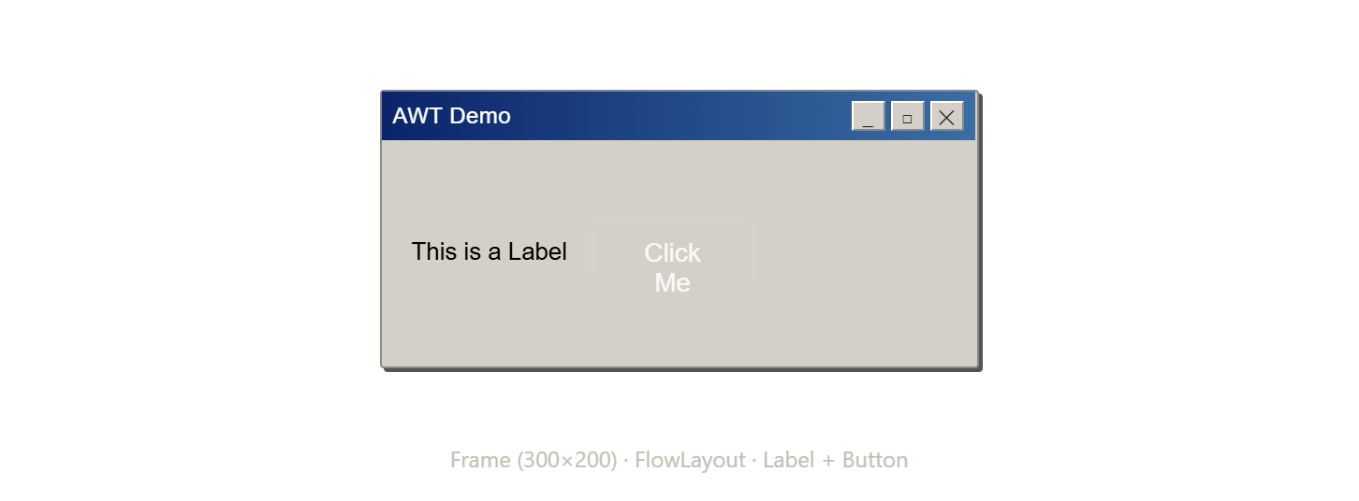

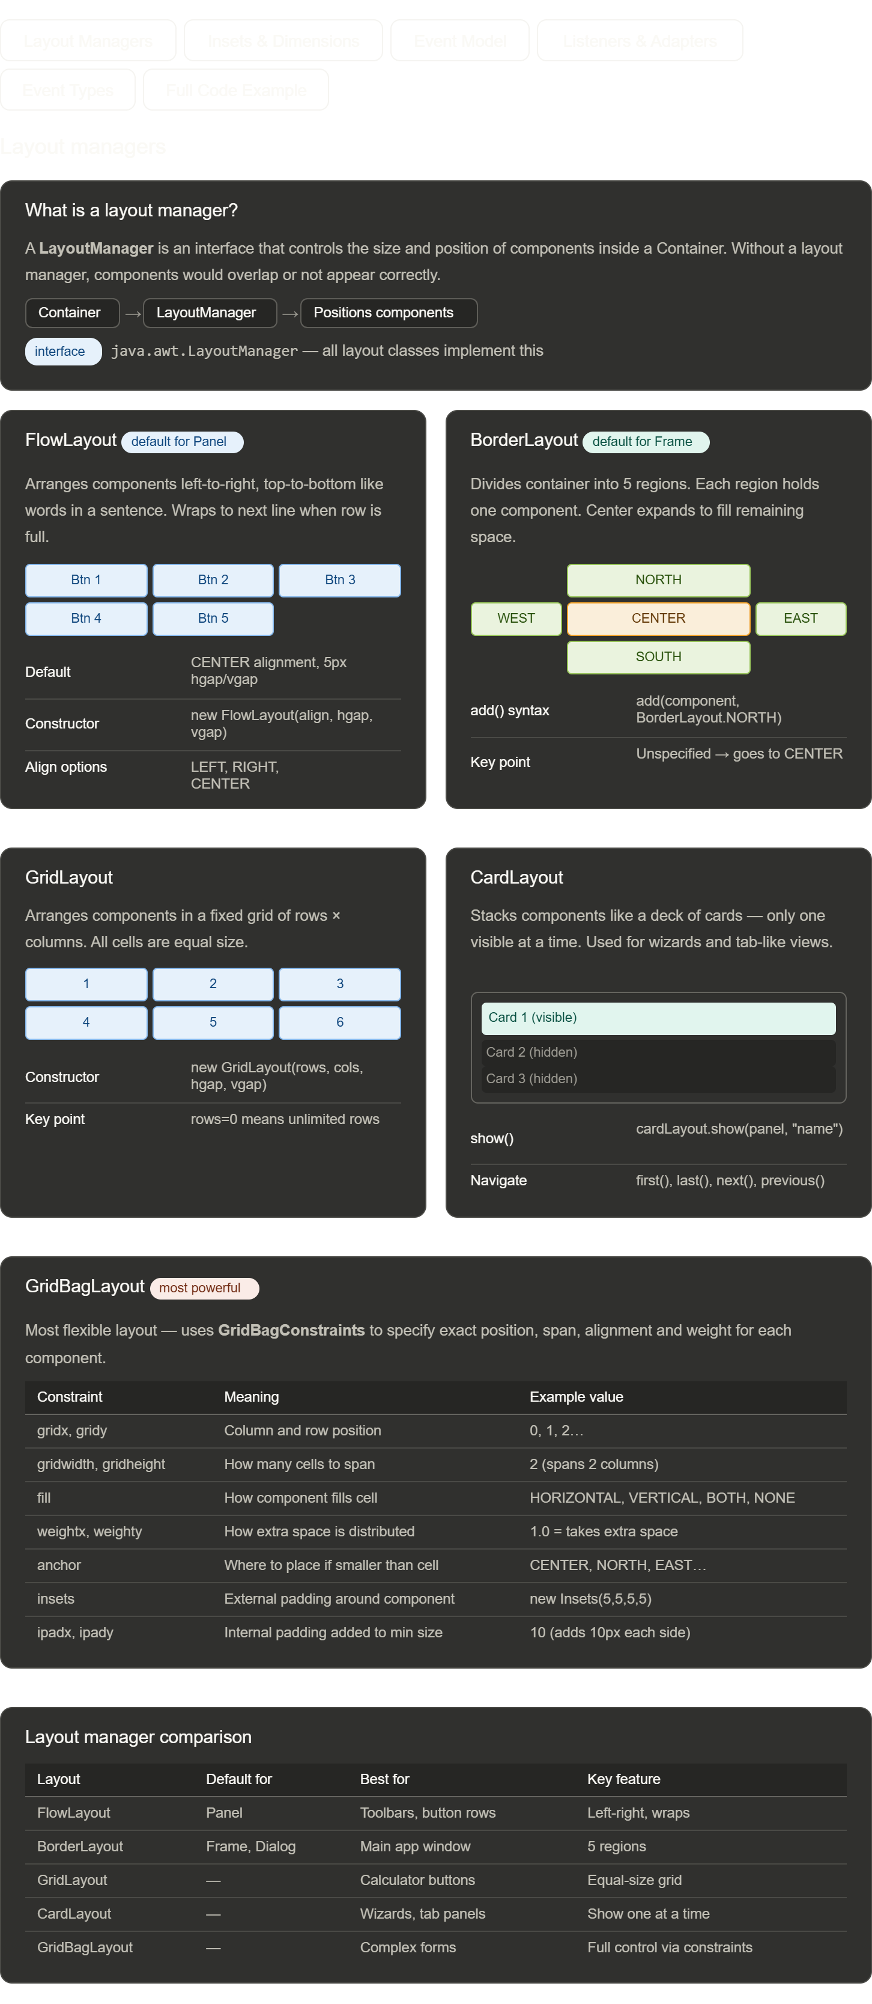
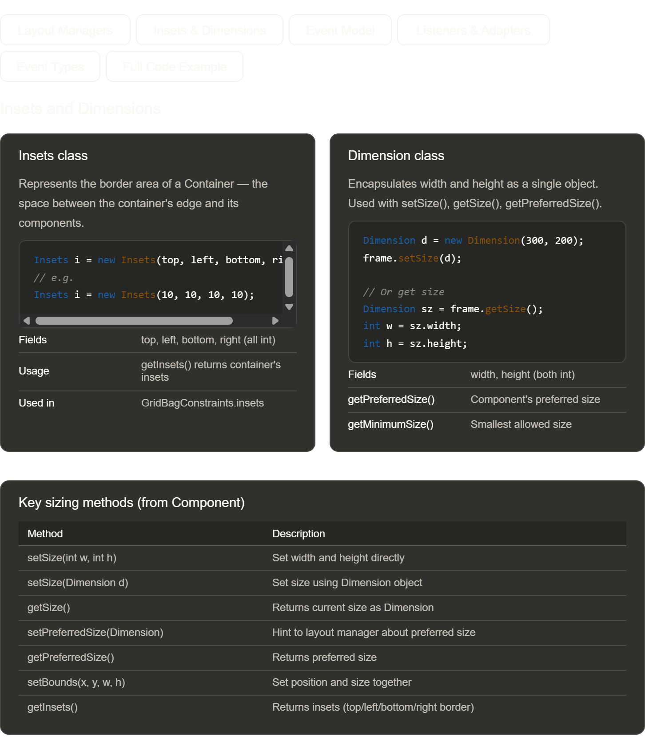
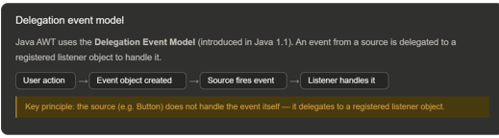
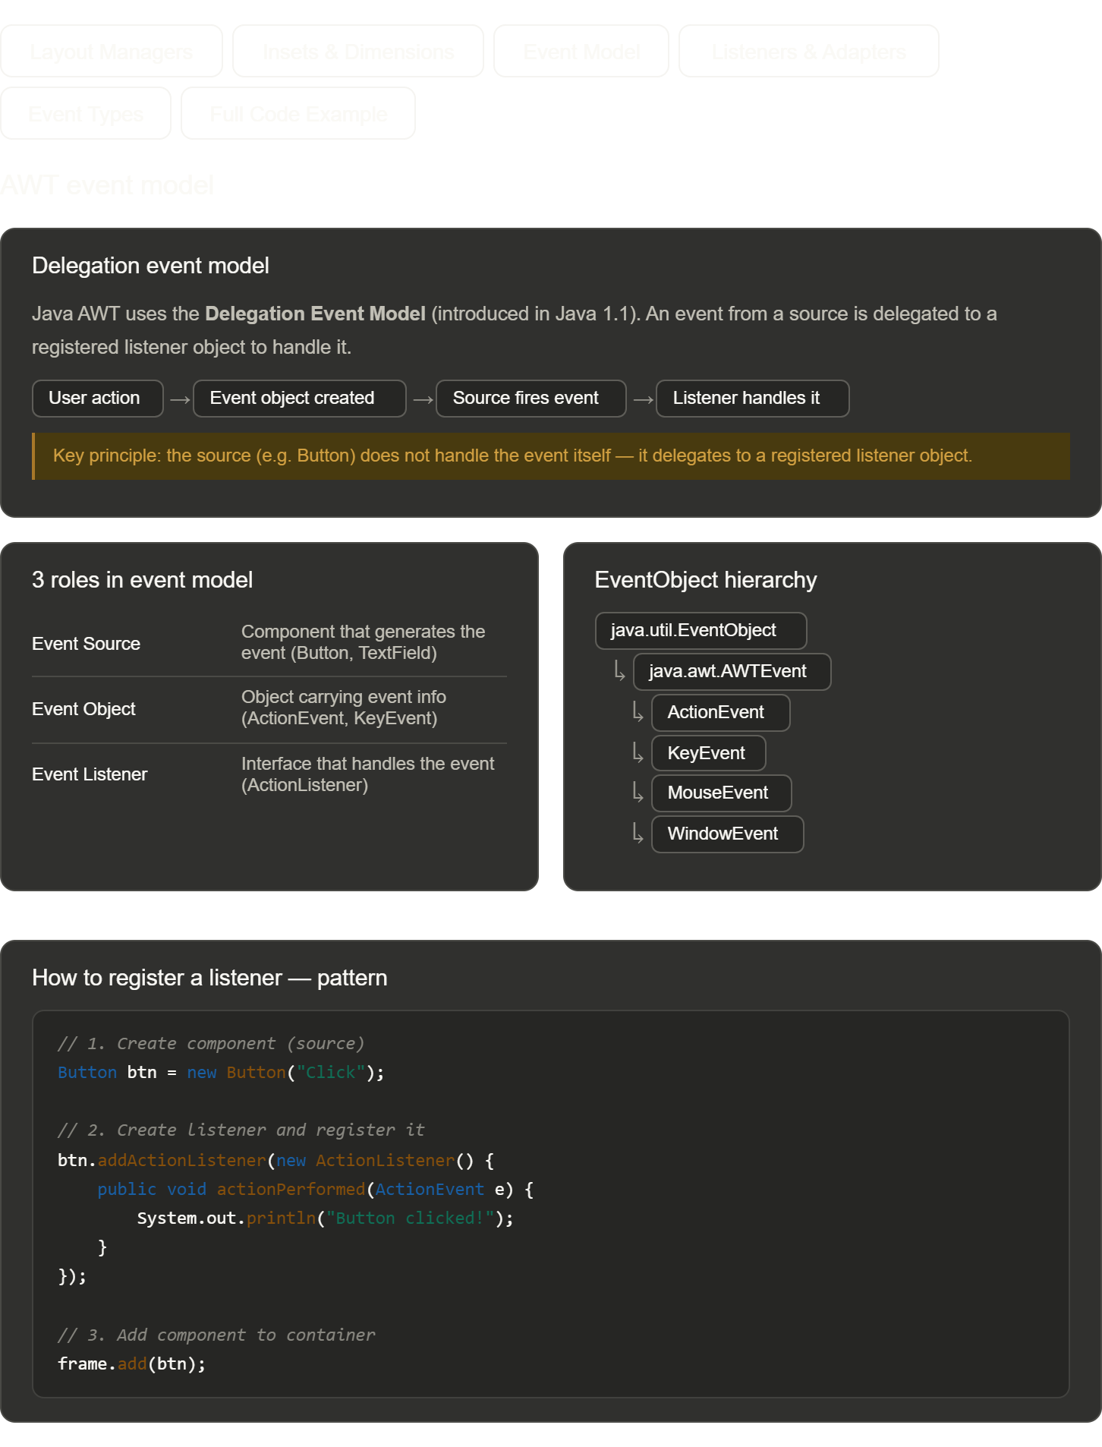
\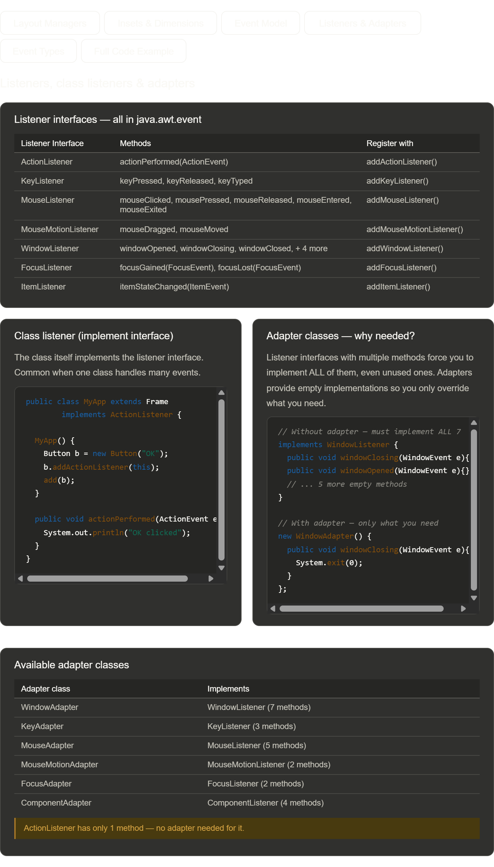
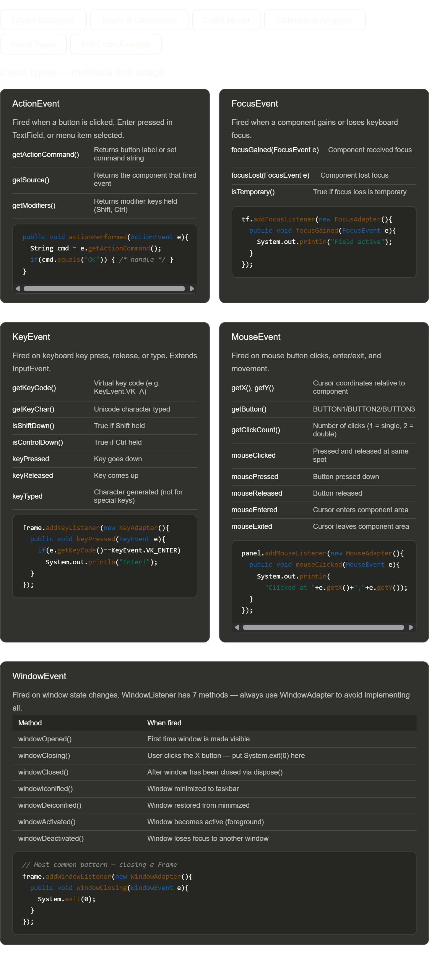
import java.awt.*;
import java.awt.event.*;
public class AWTDemo extends Frame {
public AWTDemo() {
super("AWT Demo");
setLayout(new BorderLayout());
// FlowLayout
Panel p = new Panel(new FlowLayout());
Button b = new Button("Click");
TextField tf = new TextField("type", 8);
p.add(b); p.add(tf);
// GridLayout
Panel g = new Panel(new GridLayout(2, 2));
for (int i = 1; i <= 4; i++) g.add(new Button("G" + i));
// CardLayout
CardLayout cl = new CardLayout();
Panel cp = new Panel(cl);
cp.add(new Label("Card 1"), "c1");
cp.add(new Label("Card 2"), "c2");
// GridBagLayout
Panel gb = new Panel(new GridBagLayout());
GridBagConstraints c = new GridBagConstraints();
c.gridx=0; gb.add(new Label("Name:"), c);
c.gridx=1; gb.add(new TextField(8), c);
Panel center = new Panel(new GridLayout(2, 2));
center.add(p); center.add(g); center.add(cp); center.add(gb);
add(center, BorderLayout.CENTER);
TextArea log = new TextArea(4, 40);
add(log, BorderLayout.SOUTH);
// Events
b.addActionListener(e -> log.append("Action\n"));
tf.addKeyListener(new KeyAdapter() {
public void keyPressed(KeyEvent e) { log.append("Key: " + e.getKeyChar() + "\n"); }
});
tf.addFocusListener(new FocusAdapter() {
public void focusGained(FocusEvent e) { log.append("Focus\n"); }
});
addMouseListener(new MouseAdapter() {
public void mouseClicked(MouseEvent e) { log.append("Mouse: "+e.getX()+","+e.getY()+"\n"); }
});
addWindowListener(new WindowAdapter() {
public void windowClosing(WindowEvent e) { dispose(); }
});
b.addActionListener(e -> cl.next(cp)); // also flip cards

setSize(500, 400); setVisible(true);
}
public static void main(String[] args) { new AWTDemo(); }
}

